Practical – 7

Practical Title: PHP Form Processing with Server-Side Validation and CSV/JSON File Storage

Problem Definition: Process submitted registration/contact form data using PHP. Validate and sanitize inputs on the server side and store records in CSV or JSON file format. Display success/error messages.

Theory
References for all questions:
https://www.php.net/

1. Is the form submitted using POST?
Answer: Yes, the form uses the POST method to submit data.

2. Are inputs validated and sanitized server side?
Answer: Yes, inputs are validated and sanitized using PHP.

3. Is file writing handled safely?
Answer: Yes, file writing is handled safely using PHP.

4. Are success and error responses displayed clearly?
Answer: Yes, clear success and error messages are displayed.

Implementation/ Output/Result
The form was created using HTML and PHP.
PHP was used to validate and sanitize user inputs.
The submitted data was stored in a CSV/JSON file.

Evidence of Work (Screenshots)

Description: Figure 7.1 student Registration page

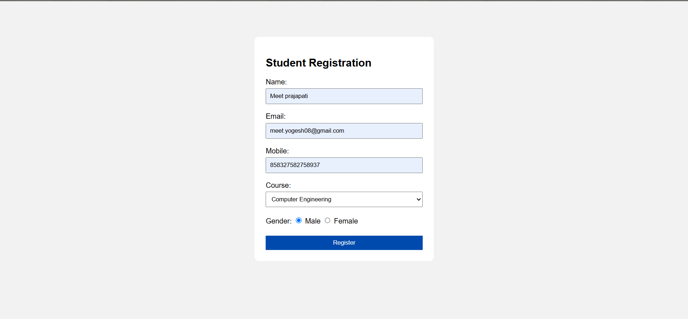

D. GitHub Repository Link:
Link: https://github.com/meetp2m/WDF-PRACTICAL-7/blob/main/index.html

Challenges Faced:

Answer: Validating user inputs using PHP.

Handling empty and invalid form data.

Storing submitted data safely in a CSV/JSON file.

F. Learning Outcomes:

Answer: Learned to process form data using PHP, validate and sanitize user inputs on the server side, store submitted data in CSV/JSON files, and display success and error messages properly.

G. Faculty Remarks:

